Code:-

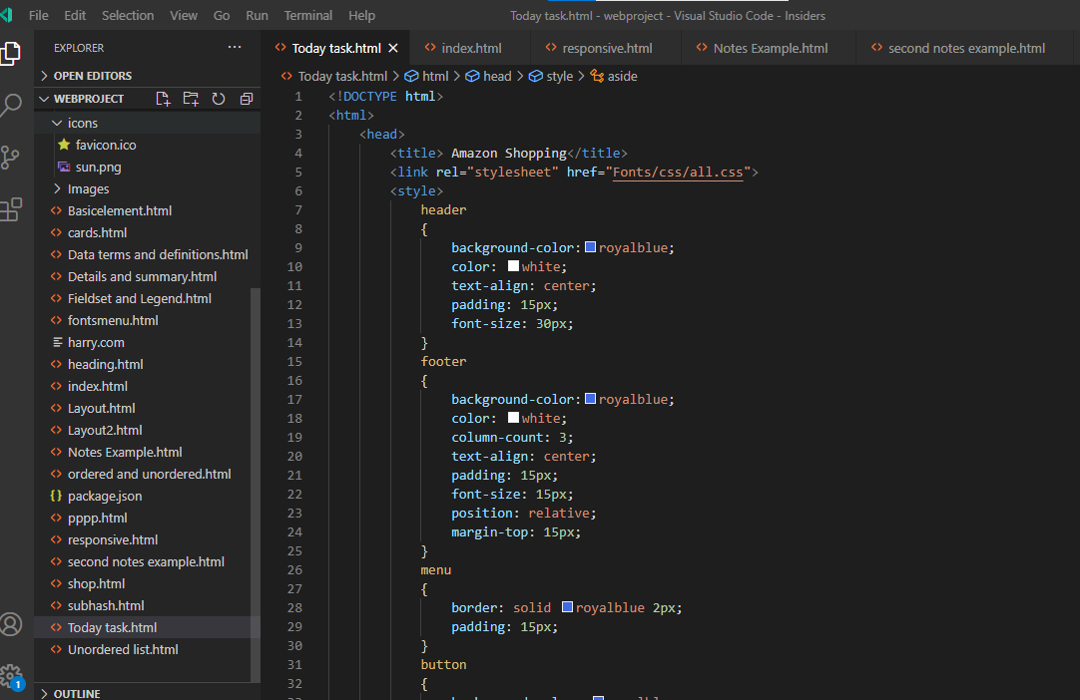

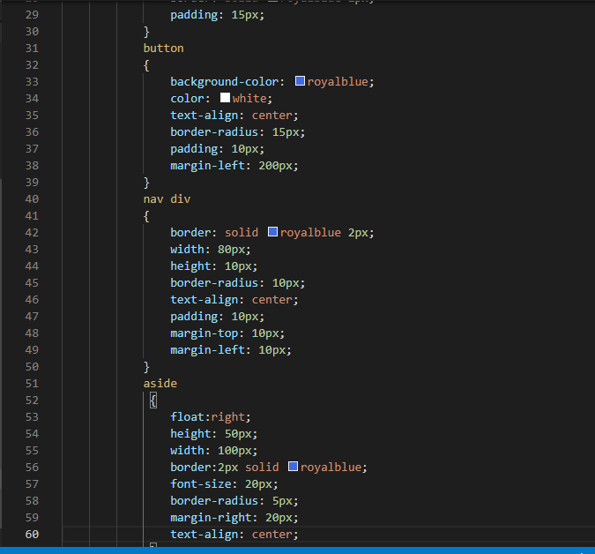

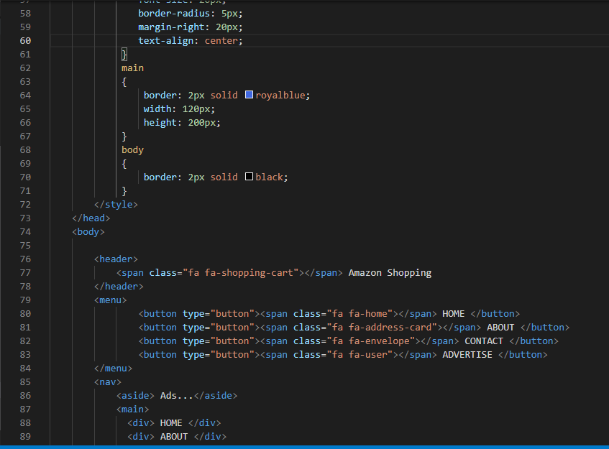

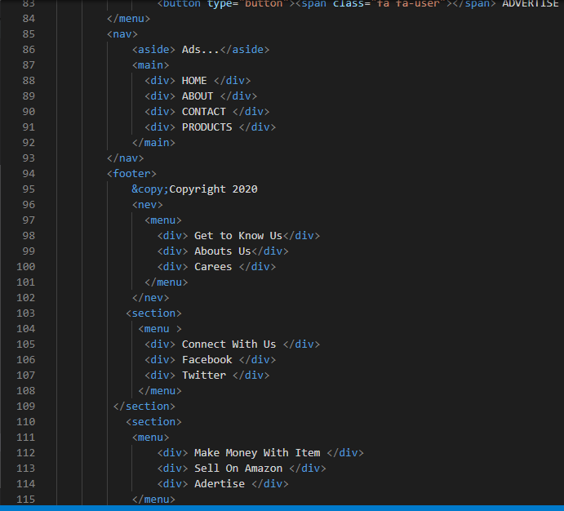

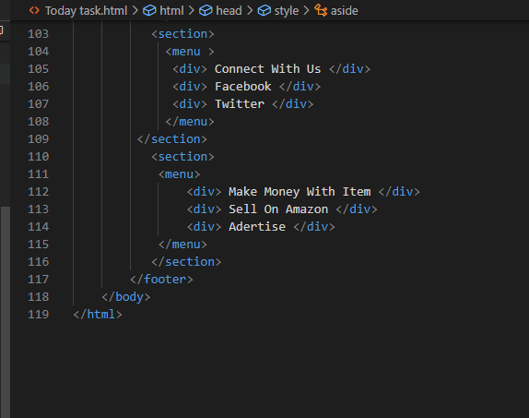

Output:-

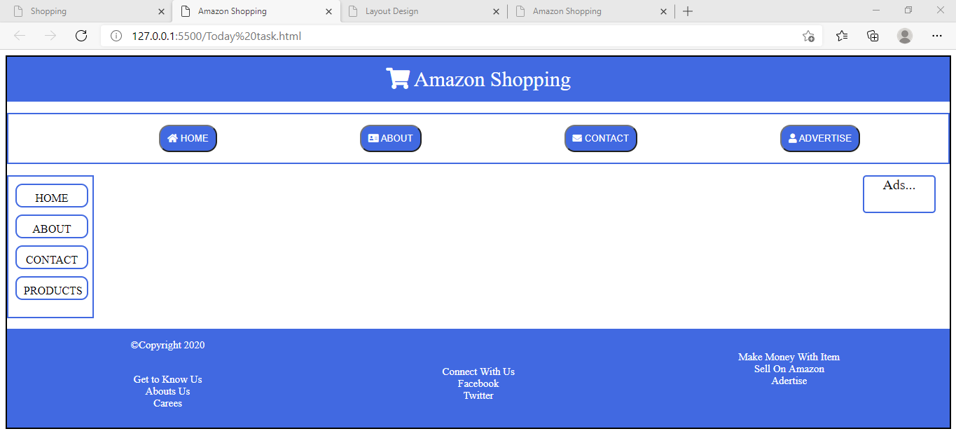

Code:-

<!DOCTYPE html>

<html>

    <head>

        <title> Amazon Banner </title>

        <link rel="stylesheet" href="Fonts/css/all.css">

        <style>

             header

            {

                background-color:royalblue;

                color: white;

                text-align: center;

                padding: 10px;

                font-size: 30px;

            }

            footer

            {

                background-color: teal;

                color: white;

                text-align: center;

                padding: 10px;

                font-size: 20px;

            }

           .box

            {

                width: 1000px;

                height: 250px;

                border: 1px solid;

                margin: 10px;

                box-shadow: 3px 5px 1px gray;

                padding: 10px;

                background-color: white;

            }

            section

            {

                display: flex;

                margin-top: -300px;

            }

            menu

            {

                display: flex;

            }

            nav

            {

              border: 1px solid black;

              background-color: rgb(117, 6, 6);

              margin-bottom: 10px;

              margin-top: 5px;

              border-radius: 5px;

              width: 100%;

              margin-top: 0px;

          }

            menu div

            {

              background-color: rgb(240, 155, 155);

              border: 1px solid white ;

              border-radius: 10px;

              height: 10px;

              width: 80px;

              color: white;

              text-align: center;

              padding: 10px;

              margin-left: 100px;

           }

           ul

           {

               display: flex;

           }

        </style>

    </head>

    <body>

        <header>

            <span class="fa fa-shopping-cart"></span> Amazon Shopping

        </header>

        <nav>

            <menu>

              <div class="fa fa-allergies">All </div>

              <div class="fa fa-home">Home</div>

              <div class="fa fa-user">Login </div>

              <div class="fa fa-id-badge">Contact</div>

              <div class="fa fa-address-card">About</div>

           </menu>

        </nav>

        <div>

            <img src="Images/Banner1 copy.jpg" width="100%" height="650px">

        </div>

        <section>

            <div class="box">

                <img src="Images/sony.png" width="100%" height="250px">

            </div>

            <div class="box">

                <img src="Images/washingbanner.png" width="100%" height="250px">

            </div>

            <div class="box">

                <img src="Images/fillip.png" width="100%" height="250px">

            </div>

        </section>

        <footer>

            <span> &copy; Copyright 2020</span>

        </footer>

    </body>

</html>

Output:-

